|  |  |  |  |
| --- | --- | --- | --- |
| **Name of Student: NINAD AVINASH PATIL** | | | |
| **Roll No: 33** | | **Lab Practical Number: 1.5** | |
| **Title of Lab Practical: Design a Tic Tac Toe game.** | | | |
| **DOP: 24/02/2021** | | **DOS: 03/03/2021** | |
| **CO Mapped: CO1** | **PO Mapped: PO3, PO5, PO7,**  **PO12, PSO1, PSO2** | **Faculty Signature:** | **Marks:** |

**Practical No 1.5**

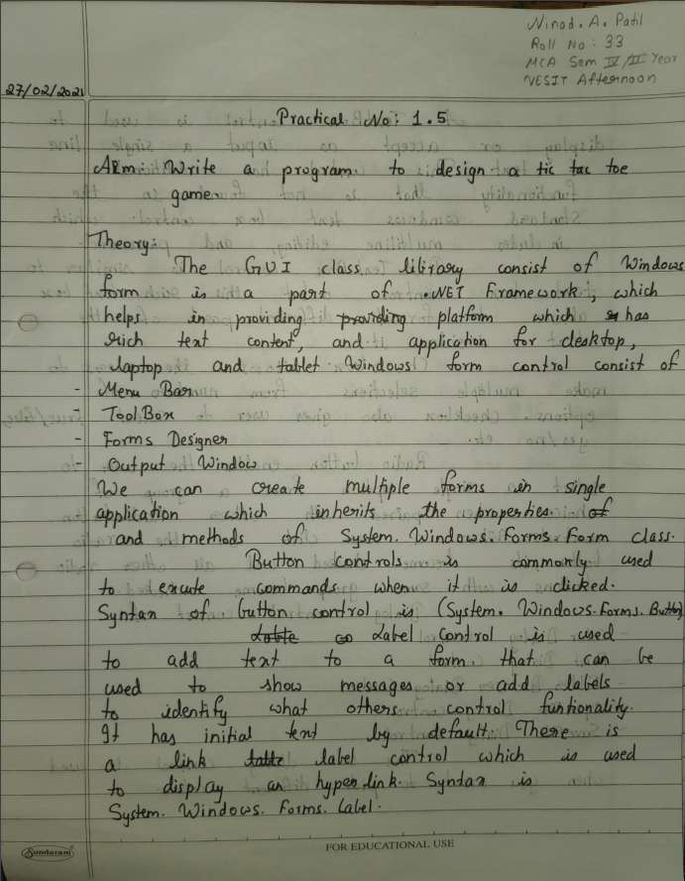

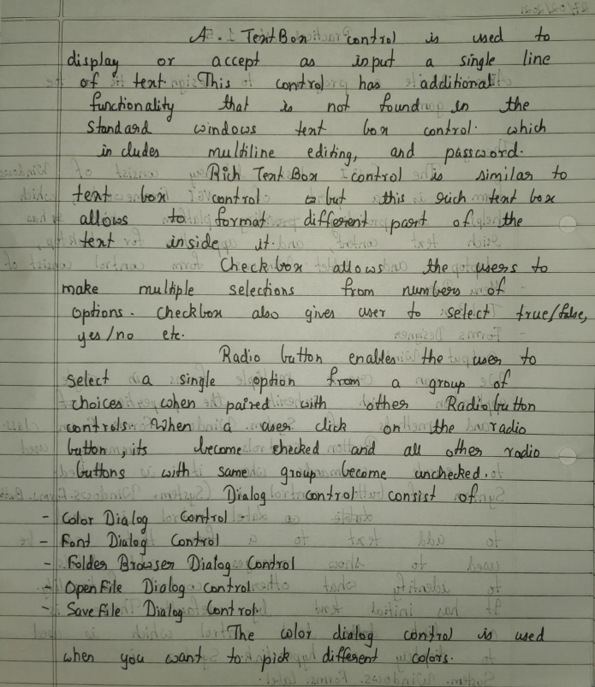

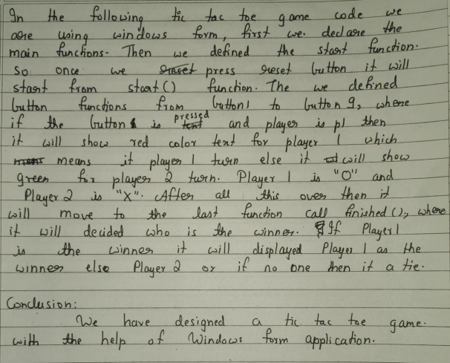

**Code:**

using System;

using System.Collections.Generic;

using System.ComponentModel;

using System.Data;

using System.Drawing;

using System.Linq;

using System.Text;

using System.Windows.Forms;

namespace WindowsFormsApplication5

{

public partial class Form1 : Form

{

Boolean p1, p2;

public Form1()

{

InitializeComponent();

start();

}

private void button1_Click(object sender, EventArgs e)

{

if (button1.Text == "")

{

if (p1 == true)

{

label2.ForeColor = Color.Green;

button1.Text = "X";

p1 = false;

p2 = true;

label2.Text = "Player 2";

}

else

{

label2.ForeColor = Color.Red;

button1.Text = "O";

p1 = true;

p2 = false;

label2.Text = "Player 1";

}

}

finished();

}

private void button2_Click(object sender, EventArgs e)

{

if (button2.Text == "")

{

if (p1 == true)

{

label2.ForeColor = Color.Green;

button2.Text = "X";

p1 = false;

p2 = true;

label2.Text = "Player 2";

}

else

{

label2.ForeColor = Color.Red;

button2.Text = "O";

p1 = true;

p2 = false;

label2.Text = "Player 1";

}

}

finished();

}

private void button3_Click(object sender, EventArgs e)

{

if (button3.Text == "")

{

if (p1 == true)

{

label2.ForeColor = Color.Green;

button3.Text = "X";

p1 = false;

p2 = true;

label2.Text = "Player 2";

}

else

{

label2.ForeColor = Color.Red;

button3.Text = "O";

p1 = true;

p2 = false;

label2.Text = "Player 1";

}

}

finished();

}

private void button4_Click(object sender, EventArgs e)

{

if (button4.Text == "")

{

if (p1 == true)

{

label2.ForeColor = Color.Green;

button4.Text = "X";

p1 = false;

p2 = true;

label2.Text = "Player 2";

}

else

{

label2.ForeColor = Color.Red;

button4.Text = "O";

p1 = true;

p2 = false;

label2.Text = "Player 1";

}

}

finished();

}

private void button5_Click(object sender, EventArgs e)

{

if (button5.Text == "")

{

if (p1 == true)

{

label2.ForeColor = Color.Green;

button5.Text = "X";

p1 = false;

p2 = true;

label2.Text = "Player 2";

}

else

{

label2.ForeColor = Color.Red;

button5.Text = "O";

p1 = true;

p2 = false;

label2.Text = "Player 1";

}

}

finished();

}

private void button6_Click(object sender, EventArgs e)

{

if (button6.Text == "")

{

if (p1 == true)

{

label2.ForeColor = Color.Green;

button6.Text = "X";

p1 = false;

p2 = true;

label2.Text = "Player 2";

}

else

{

label2.ForeColor = Color.Red;

button6.Text = "O";

p1 = true;

p2 = false;

label2.Text = "Player 1";

}

}

finished();

}

private void button7_Click(object sender, EventArgs e)

{

if (button7.Text == "")

{

if (p1 == true)

{

label2.ForeColor = Color.Green;

button7.Text = "X";

p1 = false;

p2 = true;

label2.Text = "Player 2";

}

else

{

label2.ForeColor = Color.Red;

button7.Text = "O";

p1 = true;

p2 = false;

label2.Text = "Player 1";

}

}

finished();

}

private void button8_Click(object sender, EventArgs e)

{

if (button8.Text == "")

{

if (p1 == true)

{

label2.ForeColor = Color.Green;

button8.Text = "X";

p1 = false;

p2 = true;

label2.Text = "Player 2";

}

else

{

label2.ForeColor = Color.Red;

button8.Text = "O";

p1 = true;

p2 = false;

label2.Text = "Player 1";

}

}

finished();

}

private void button9_Click(object sender, EventArgs e)

{

if (button9.Text == "")

{

if (p1 == true)

{

label2.ForeColor = Color.Green;

button9.Text = "X";

p1 = false;

p2 = true;

label2.Text = "Player 2";

}

else

{

label2.ForeColor = Color.Red;

button9.Text = "O";

p1 = true;

p2 = false;

label2.Text = "Player 1";

}

}

finished();

}

void finished()

{

if ((button1.Text == "X" && button2.Text == "X" && button3.Text == "X") ||

(button1.Text == "X" && button4.Text == "X" && button7.Text == "X") ||

(button1.Text == "X" && button5.Text == "X" && button9.Text == "X") ||

(button3.Text == "X" && button5.Text == "X" && button7.Text == "X") ||

(button2.Text == "X" && button5.Text == "X" && button8.Text == "X") ||

(button3.Text == "X" && button6.Text == "X" && button9.Text == "X") ||

(button4.Text == "X" && button5.Text == "X" && button6.Text == "X") ||

(button7.Text == "X" && button8.Text == "X" && button9.Text == "X"))

{

MessageBox.Show("Winner is : Player 1");

start();

}

else if ((button1.Text == "O" && button2.Text == "O" && button3.Text == "O") ||

(button1.Text == "O" && button4.Text == "O" && button7.Text == "O") ||

(button1.Text == "O" && button5.Text == "O" && button9.Text == "O") ||

(button3.Text == "O" && button5.Text == "O" && button7.Text == "O") ||

(button2.Text == "O" && button5.Text == "O" && button8.Text == "O") ||

(button3.Text == "O" && button6.Text == "O" && button9.Text == "O") ||

(button4.Text == "O" && button5.Text == "O" && button6.Text == "O") ||

(button7.Text == "O" && button8.Text == "O" && button9.Text == "O"))

{

MessageBox.Show("Winner is : Player 2");

start();

}

else if (button1.Text != "" && button2.Text != "" && button3.Text != ""

&& button4.Text != "" && button5.Text != "" && button6.Text != ""

&& button7.Text != "" && button8.Text != "" && button9.Text != "")

{

MessageBox.Show("Its a tie");

start();

}

}

public void start()

{

button1.Text = "";

button2.Text = "";

button3.Text = "";

button4.Text = "";

button5.Text = "";

button6.Text = "";

button7.Text = "";

button8.Text = "";

button9.Text = "";

label2.Text = "Player 1";

label2.ForeColor = Color.Red;

p1 = true;

p2 = false;

}

private void button11_Click(object sender, EventArgs e)

{

start();

}

}

}

**Output:**

